UNITED STATES
SECURITIES AND EXCHANGE COMMISSION
WASHINGTON, D.C. 20549

FORM 8-K

CURRENT REPORT
PURSUANT TO SECTION 13 OR 15(d) OF THE
SECURITIES EXCHANGE ACT OF 1934

Date of Report (Date of earliest event reported): September 1, 2026

CNO Financial Group, Inc.
(Exact Name of Registrant as Specified in Charter)

Delaware |  |  | 001-31792 |  |  | 75-3108137
(State or Other  Jurisdiction of Incorporation) |  |  | (Commission File Number) |  |  | (I.R.S. Employer  Identification No.)
11299 Illinois Street
Carmel, Indiana 46032
(Address of Principal Executive Offices) (Zip Code)

(317) 817-6100
(Registrant's telephone number, including area code)

Check the appropriate box below if the Form 8-K filing is intended to simultaneously satisfy the filing obligation of the registrant under any of the following provisions:
☐ |  |  | Written communications pursuant to Rule 425 under the Securities Act (17 CFR 230.425)
☐ |  |  | Soliciting material pursuant to Rule 14a-12 under the Exchange Act (17 CFR 240.14a-12)
☐ |  |  | Pre-commencement communications pursuant to Rule 14d-2(b) under the Exchange Act (17 CFR 240.14d-2(b))
☐ |  |  | Pre-commencement communications pursuant to Rule 13e-4(c) under the Exchange Act (17 CFR 240.13e-4(c))

Securities registered pursuant to Section 12(b) of the Act:
Title of each class |  |  |  |  |  | Trading Symbol |  |  |  |  |  | Name of each exchange on which registered
Common Stock, par value $0.01 per share |  |  |  |  |  | CNO |  |  |  |  |  | New York Stock Exchange
Rights to purchase Series F Junior Participating Preferred Stock |  |  |  |  |  |  |  |  |  |  |  | New York Stock Exchange
5.125% Subordinated Debentures due 2060 |  |  |  |  |  | CNOpA |  |  |  |  |  | New York Stock Exchange

Indicate by check mark whether the registrant is an emerging growth company as defined in Rule 405 of the Securities Act of 1933 (§230.405 of this chapter) or Rule 12b-2 of the Securities Exchange Act of 1934 (§240.12b-2 of this chapter).

Emerging growth company ☐

If an emerging growth company, indicate by check mark if the registrant has elected not to use the extended transition period for complying with any new or revised financial accounting standards provided pursuant to Section 13(a) of the Exchange Act. ☐

Item 7.01. |  |  | Regulation FD Disclosure.

On September 1, 2026, CNO Financial Group, Inc. (the "Company") issued a presentation for its upcoming investor briefing focused on its Worksite Division and Medicare business. This presentation and future updates to this presentation will be posted in the Investors section of the Company's website: ir.CNOinc.com. A copy of this information is attached hereto as Exhibit 99.1 and is incorporated herein by reference.

The information contained in this Current Report on Form 8-K (including Exhibit 99.1) is being furnished and shall not be deemed "filed" for purposes of Section 18 of the Securities and Exchange Act of 1934, as amended (the "Exchange Act"), or otherwise subject to the liabilities of that Section. The information contained in this Current Report on Form 8-K shall not be incorporated by reference into any registration statement or other document pursuant to the Securities Act of 1933, as amended, or the Exchange Act, except as shall be expressly set forth by specific reference in any such filing.

Item 9.01(d). |  |  | Financial Statements and Exhibits.

The following materials are furnished as exhibits to this Current Report on Form 8-K:

99.1 |  |  | Worksite Division and Medicare business Investor Briefing - September 2026.
104 |  |  | Cover Page Interactive Data File (embedded within the Inline XBRL document).

2

SIGNATURES

Pursuant to the requirements of the Securities Exchange Act of 1934, the Registrant has duly caused this report to be signed on its behalf by the undersigned hereunto duly authorized.
 |  |  | CNO Financial Group, Inc.
Date: September 1, 2026
 |  |  | By: |  |  | /s/ Joel T. Koehneman
 |  |  |  |  |  | Joel T. Koehneman
Senior Vice President and
Chief Accounting Officer

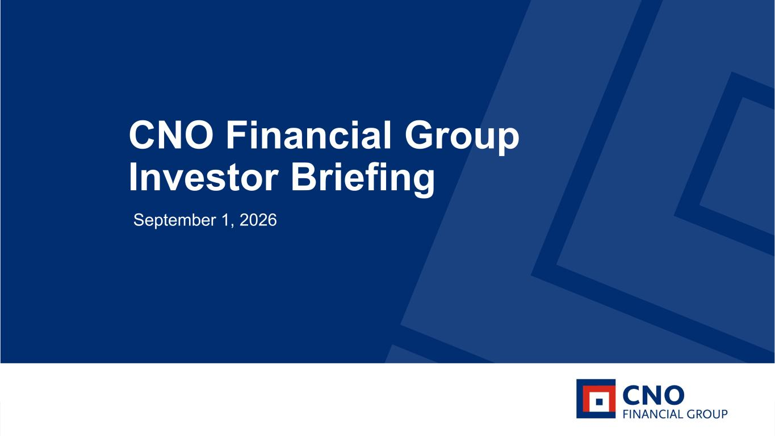
3
1CNO Financial Group | Investor Briefing | September 1, 2026 CNO Financial Group Investor Briefing September 1, 2026

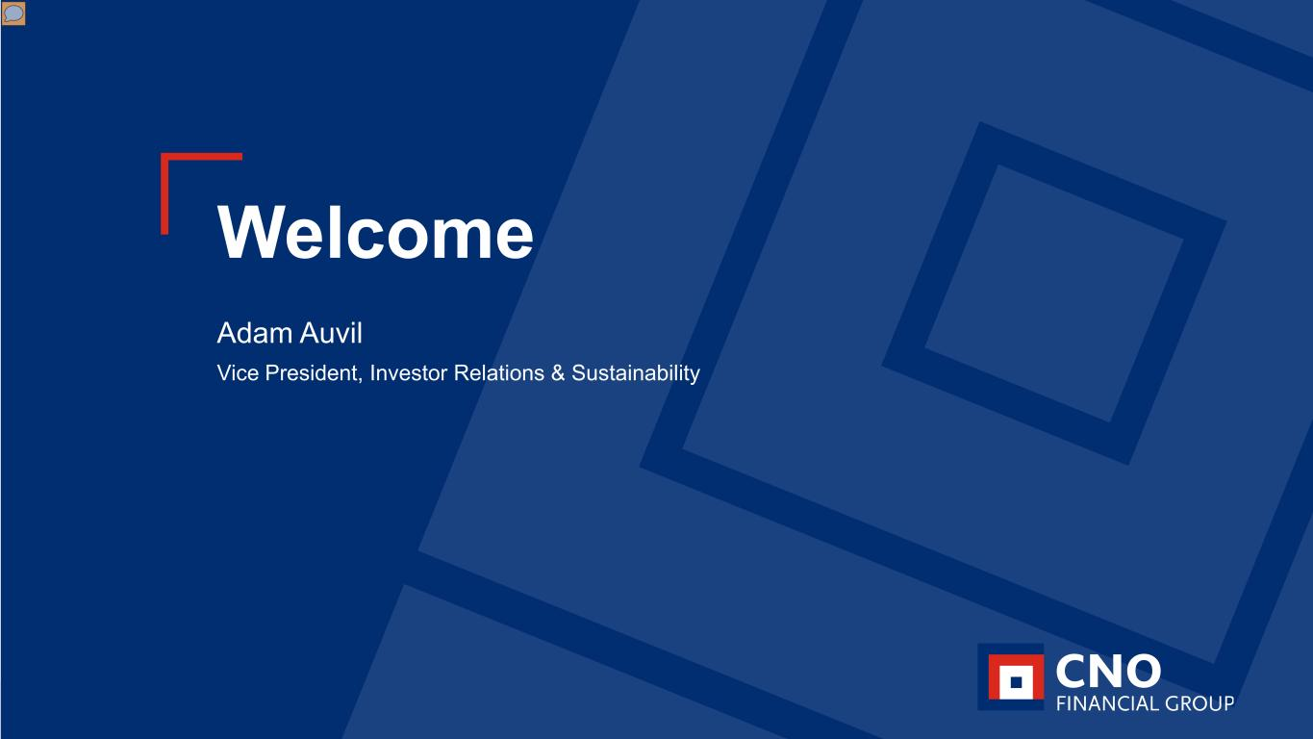
2CNO Financial Group | Investor Briefing | September 1, 2026 Welcome Adam Auvil Vice President, Investor Relations & Sustainability

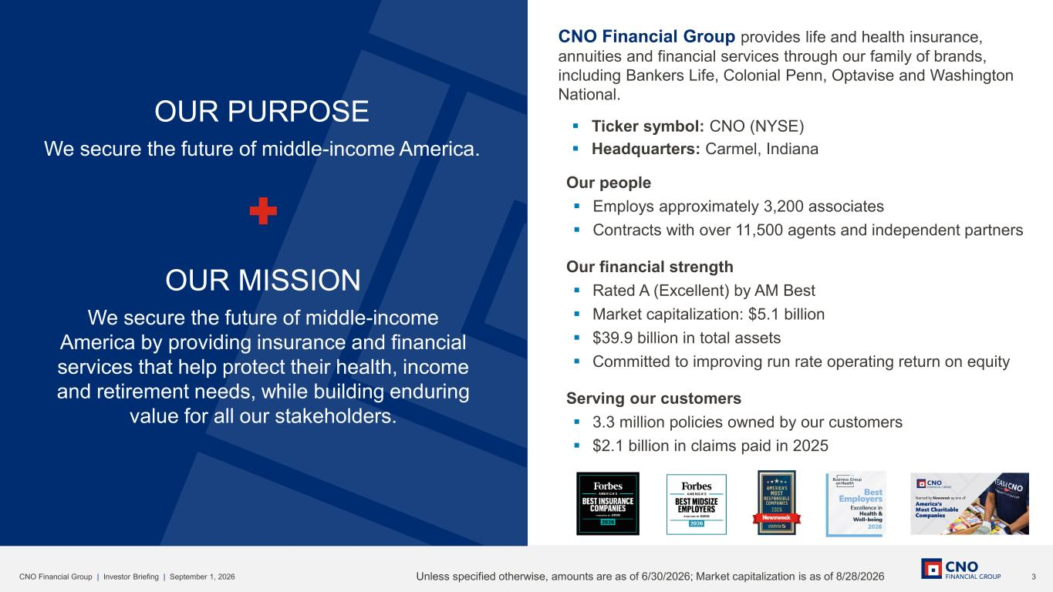
3CNO Financial Group | Investor Briefing | September 1, 2026 OUR PURPOSE We secure the future of middle-income America. OUR MISSION We secure the future of middle-income America by providing insurance and financial services that help protect their health, income and retirement needs, while building enduring value for all our stakeholders. Our people ▪ Employs approximately 3,200 associates ▪ Contracts with over 11,500 agents and independent partners Our financial strength ▪ Rated A (Excellent) by AM Best ▪ Market capitalization: $5.1 billion ▪ $39.9 billion in total assets ▪ Committed to improving run rate operating return on equity Serving our customers ▪ 3.3 million policies owned by our customers ▪ $2.1 billion in claims paid in 2025 CNO Financial Group provides life and health insurance, annuities and financial services through our family of brands, including Bankers Life, Colonial Penn, Optavise and Washington National. ▪ Ticker symbol: CNO (NYSE) ▪ Headquarters: Carmel, Indiana Unless specified otherwise, amounts are as of 6/30/2026; Market capitalization is as of 8/28/2026

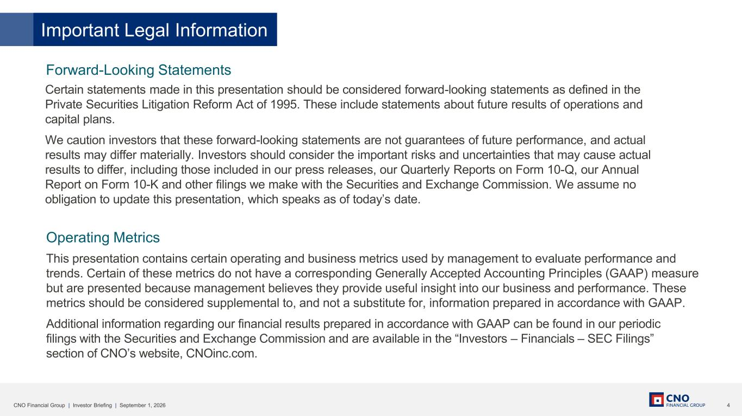
4CNO Financial Group | Investor Briefing | September 1, 2026 Important Legal Information Certain statements made in this presentation should be considered forward-looking statements as defined in the Private Securities Litigation Reform Act of 1995. These include statements about future results of operations and capital plans. We caution investors that these forward-looking statements are not guarantees of future performance, and actual results may differ materially. Investors should consider the important risks and uncertainties that may cause actual results to differ, including those included in our press releases, our Quarterly Reports on Form 10-Q, our Annual Report on Form 10-K and other filings we make with the Securities and Exchange Commission. We assume no obligation to update this presentation, which speaks as of today’s date. This presentation contains certain operating and business metrics used by management to evaluate performance and trends. Certain of these metrics do not have a corresponding Generally Accepted Accounting Principles (GAAP) measure but are presented because management believes they provide useful insight into our business and performance. These metrics should be considered supplemental to, and not a substitute for, information prepared in accordance with GAAP. Additional information regarding our financial results prepared in accordance with GAAP can be found in our periodic filings with the Securities and Exchange Commission and are available in the “Investors – Financials – SEC Filings” section of CNO’s website, CNOinc.com. Forward-Looking Statements Operating Metrics

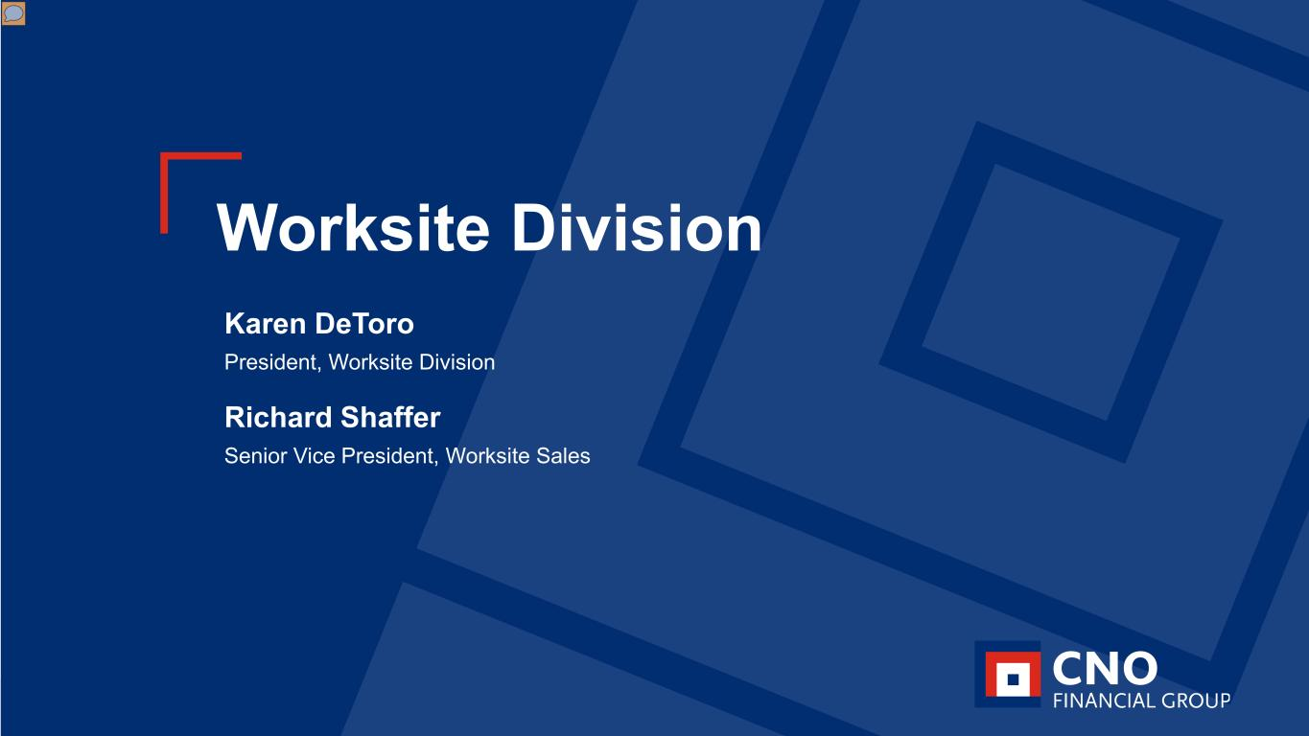
5CNO Financial Group | Investor Briefing | September 1, 2026 Worksite Division Karen DeToro President, Worksite Division Richard Shaffer Senior Vice President, Worksite Sales

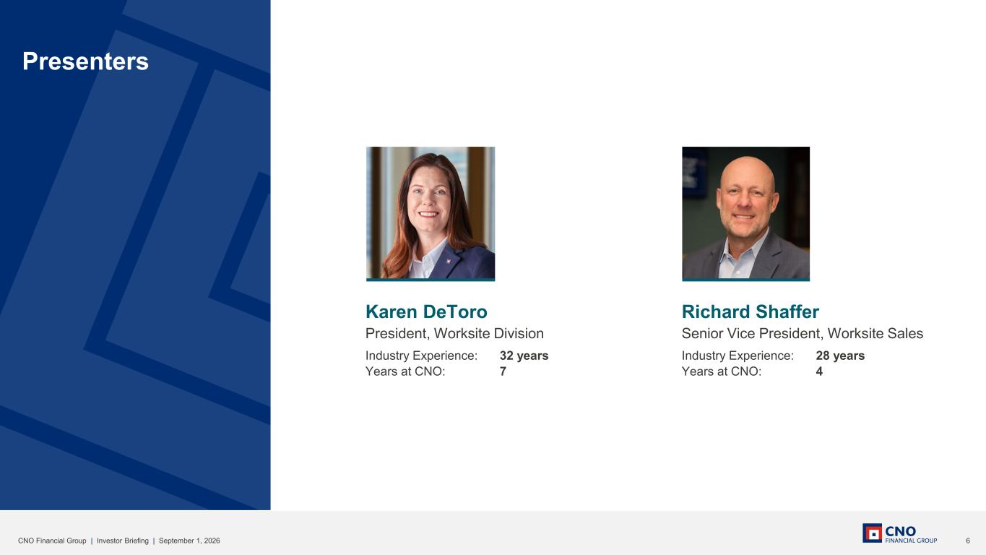
6CNO Financial Group | Investor Briefing | September 1, 2026 Presenters Karen DeToro President, Worksite Division Industry Experience: 32 years Years at CNO: 7 Richard Shaffer Senior Vice President, Worksite Sales Industry Experience: 28 years Years at CNO: 4

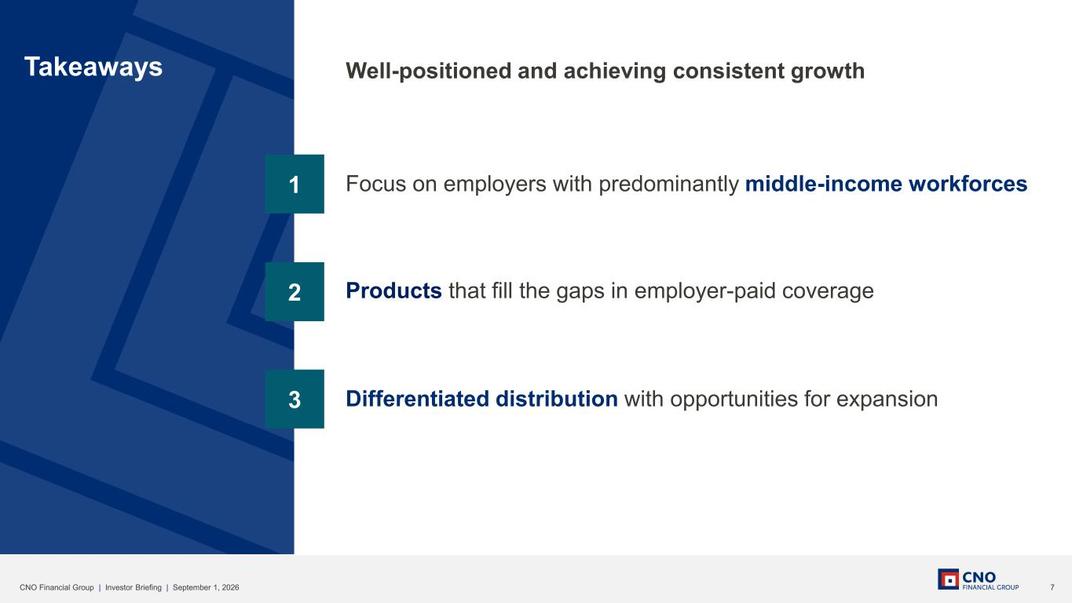
7CNO Financial Group | Investor Briefing | September 1, 2026 3 2 1 Takeaways Focus on employers with predominantly middle-income workforces Products that fill the gaps in employer-paid coverage Differentiated distribution with opportunities for expansion Well-positioned and achieving consistent growth

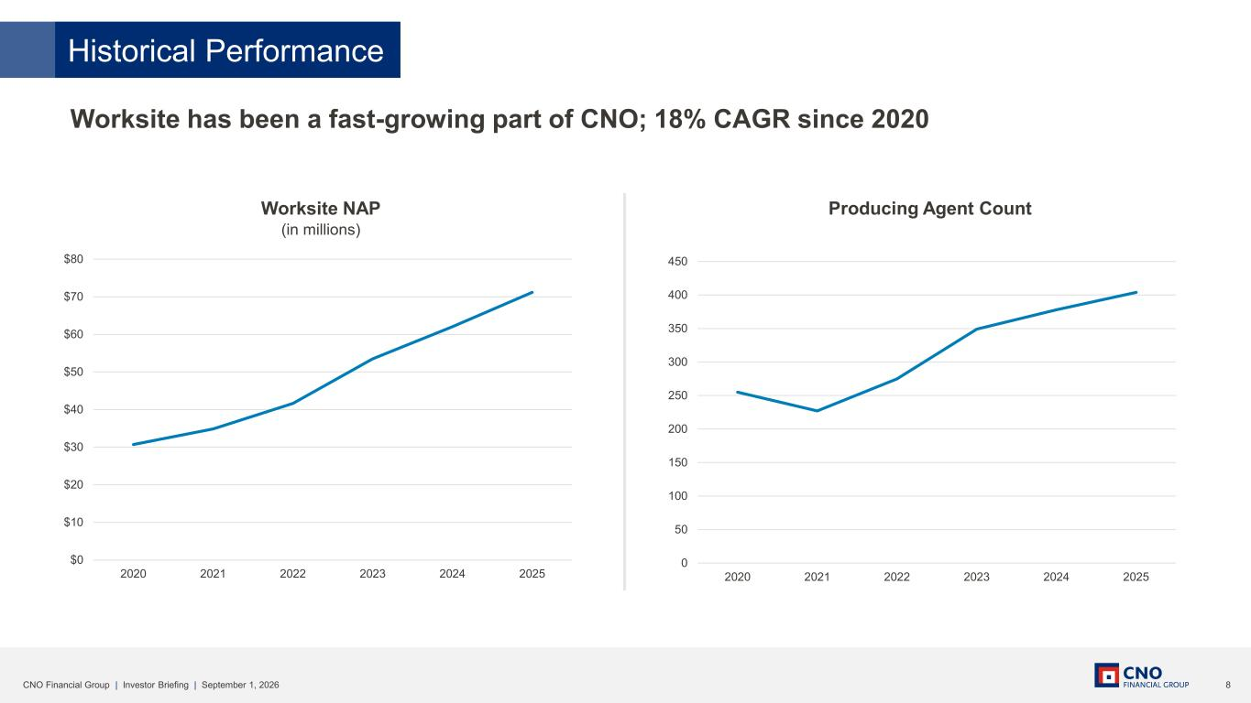
8CNO Financial Group | Investor Briefing | September 1, 2026 Worksite NAP (in millions) Producing Agent Count Worksite has been a fast-growing part of CNO; 18% CAGR since 2020 $0 $10 $20 $30 $40 $50 $60 $70 $80 2020 2021 2022 2023 2024 2025 0 50 100 150 200 250 300 350 400 450 2020 2021 2022 2023 2024 2025 Historical Performance

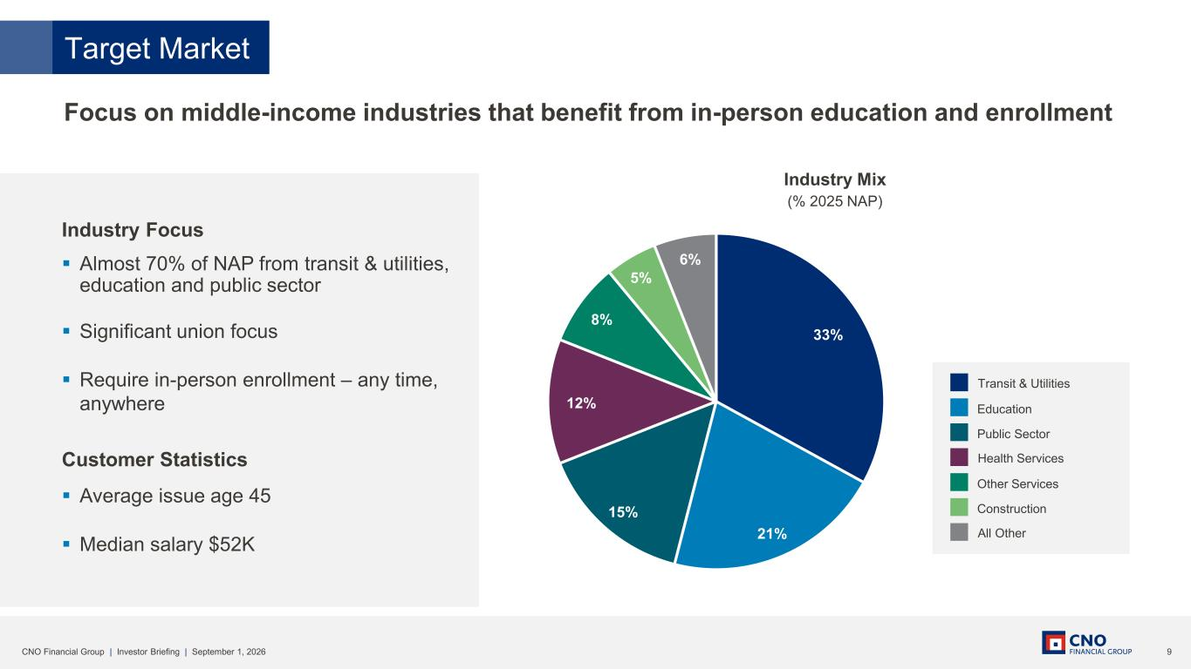
9CNO Financial Group | Investor Briefing | September 1, 2026 Industry Focus ▪ Almost 70% of NAP from transit & utilities, education and public sector ▪ Significant union focus ▪ Require in-person enrollment – any time, anywhere Customer Statistics ▪ Average issue age 45 ▪ Median salary $52K Focus on middle-income industries that benefit from in-person education and enrollment 33% 21% 15% 12% 8% 5% 6% Target Market Industry Mix (% 2025 NAP) Health Services Other Services Construction All Other Transit & Utilities Education Public Sector

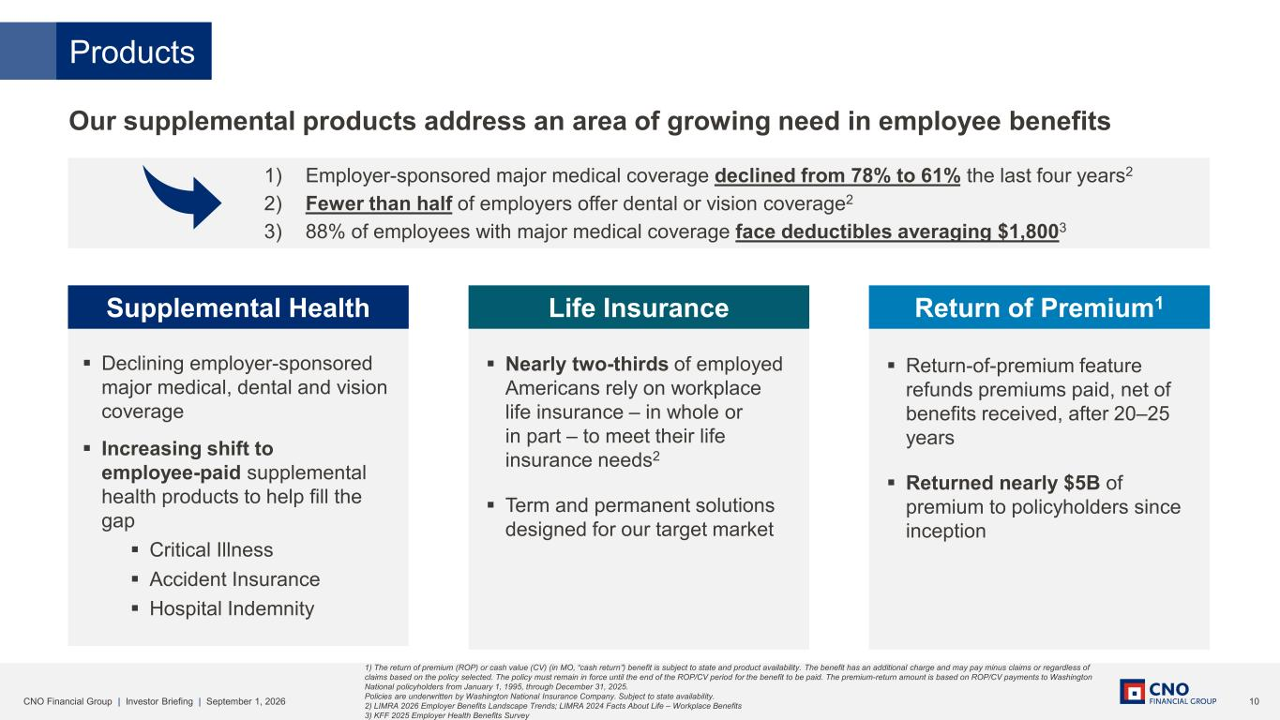
10CNO Financial Group | Investor Briefing | September 1, 2026 ▪ Return-of-premium feature refunds premiums paid, net of benefits received, after 20–25 years ▪ Returned nearly $5B of premium to policyholders since inception Supplemental Health ▪ Nearly two-thirds of employed Americans rely on workplace life insurance – in whole or in part – to meet their life insurance needs2 ▪ Term and permanent solutions designed for our target market Life Insurance Return of Premium1 Products ▪ Declining employer-sponsored major medical, dental and vision coverage ▪ Increasing shift to employee-paid supplemental health products to help fill the gap ▪ Critical Illness ▪ Accident Insurance ▪ Hospital Indemnity Our supplemental products address an area of growing need in employee benefits 1) The return of premium (ROP) or cash value (CV) (in MO, “cash return”) benefit is subject to state and product availability. The benefit has an additional charge and may pay minus claims or regardless of claims based on the policy selected. The policy must remain in force until the end of the ROP/CV period for the benefit to be paid. The premium-return amount is based on ROP/CV payments to Washington National policyholders from January 1, 1995, through December 31, 2025. Policies are underwritten by Washington National Insurance Company. Subject to state availability. 2) LIMRA 2026 Employer Benefits Landscape Trends; LIMRA 2024 Facts About Life – Workplace Benefits 3) KFF 2025 Employer Health Benefits Survey 1) Employer-sponsored major medical coverage declined from 78% to 61% the last four years2 2) Fewer than half of employers offer dental or vision coverage2 3) 88% of employees with major medical coverage face deductibles averaging $1,8003

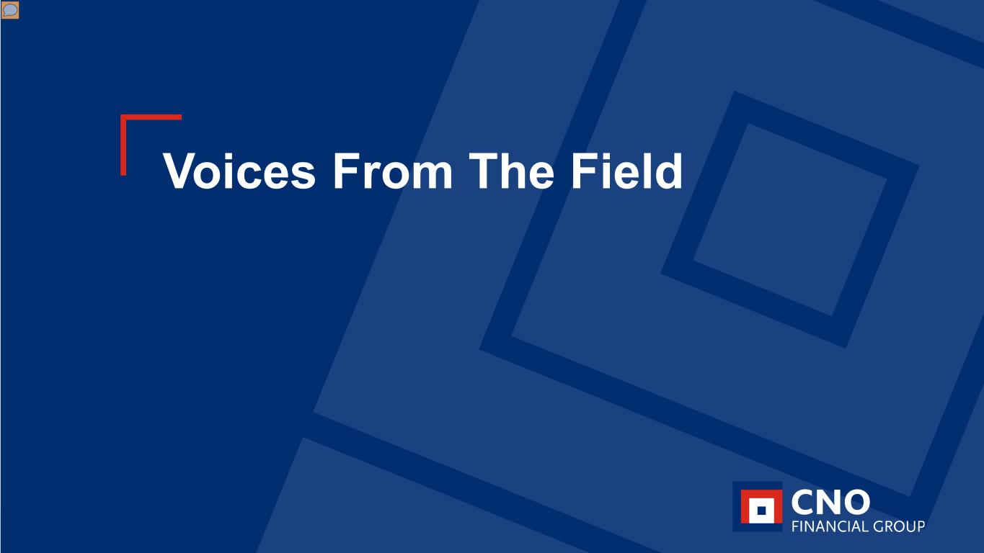
11CNO Financial Group | Investor Briefing | September 1, 2026 Voices From The Field

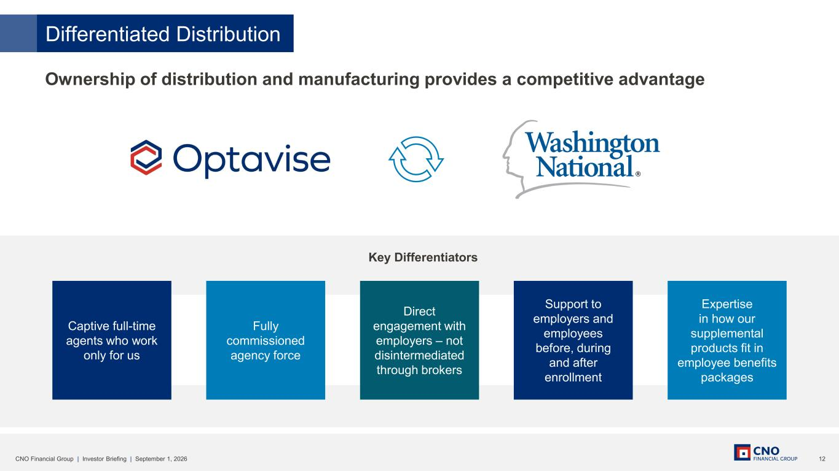
12CNO Financial Group | Investor Briefing | September 1, 2026 Ownership of distribution and manufacturing provides a competitive advantage Differentiated Distribution Key Differentiators Support to employers and employees before, during and after enrollment Captive full-time agents who work only for us Direct engagement with employers – not disintermediated through brokers Fully commissioned agency force Expertise in how our supplemental products fit in employee benefits packages

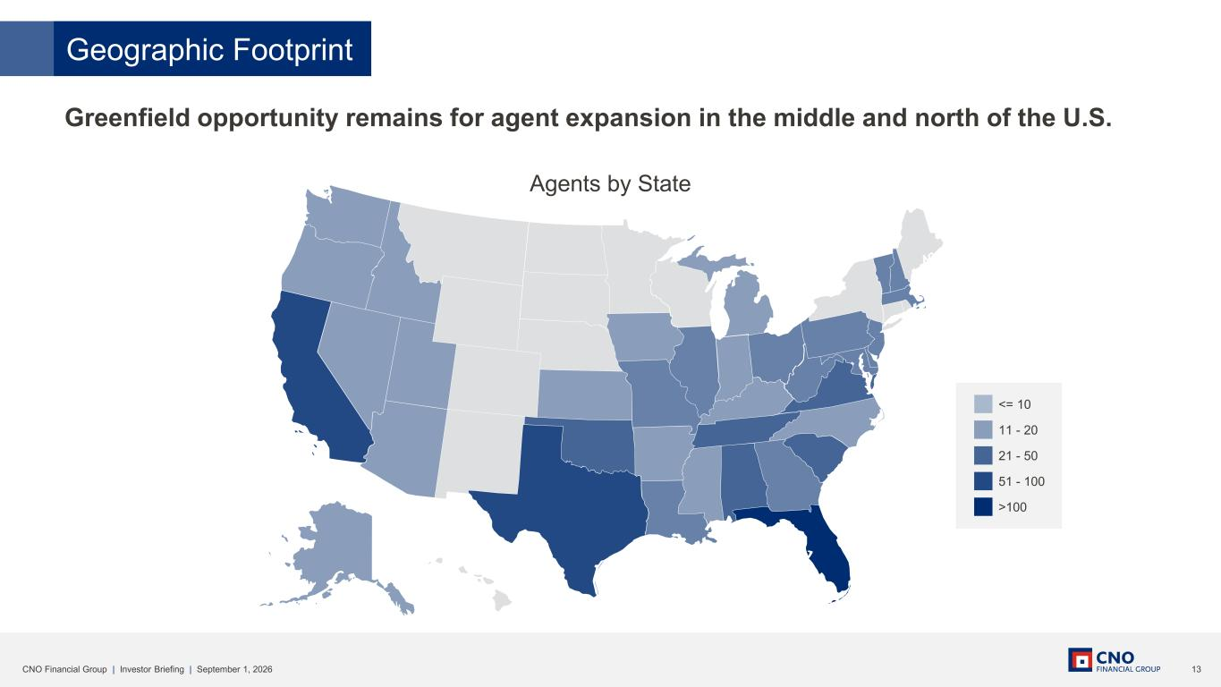
13CNO Financial Group | Investor Briefing | September 1, 2026 Greenfield opportunity remains for agent expansion in the middle and north of the U.S. Geographic Footprint <= 10 11 - 20 21 - 50 51 - 100 >100 Agents by State

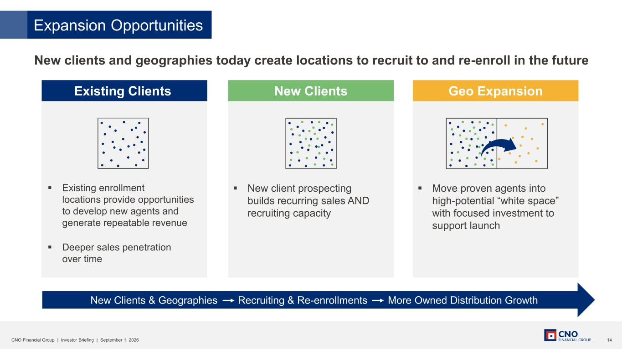
14CNO Financial Group | Investor Briefing | September 1, 2026 New clients and geographies today create locations to recruit to and re-enroll in the future Expansion Opportunities Existing Clients New Clients Geo Expansion New Clients & Geographies Recruiting & Re-enrollments More Owned Distribution Growth ▪ Existing enrollment locations provide opportunities to develop new agents and generate repeatable revenue ▪ Deeper sales penetration over time ▪ New client prospecting builds recurring sales AND recruiting capacity ▪ Move proven agents into high-potential “white space” with focused investment to support launch

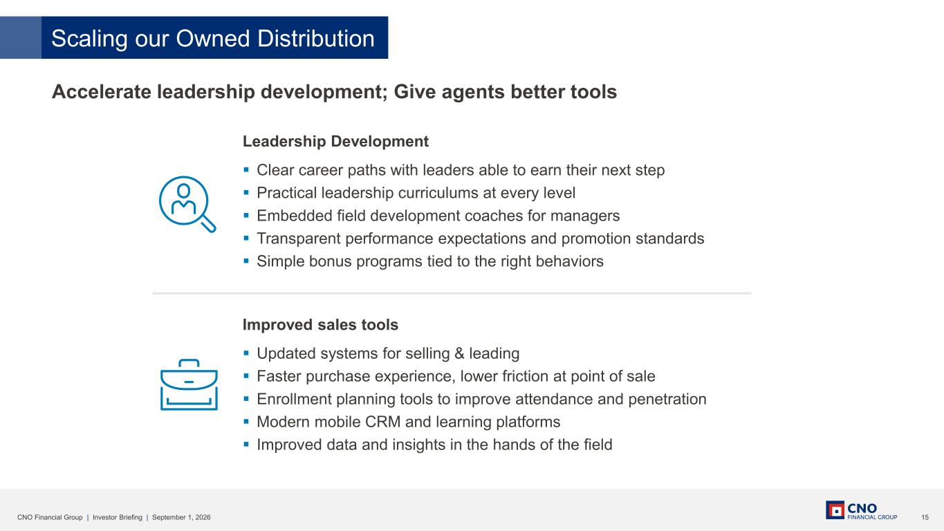
15CNO Financial Group | Investor Briefing | September 1, 2026 Accelerate leadership development; Give agents better tools Leadership Development ▪ Clear career paths with leaders able to earn their next step ▪ Practical leadership curriculums at every level ▪ Embedded field development coaches for managers ▪ Transparent performance expectations and promotion standards ▪ Simple bonus programs tied to the right behaviors Improved sales tools ▪ Updated systems for selling & leading ▪ Faster purchase experience, lower friction at point of sale ▪ Enrollment planning tools to improve attendance and penetration ▪ Modern mobile CRM and learning platforms ▪ Improved data and insights in the hands of the field Scaling our Owned Distribution

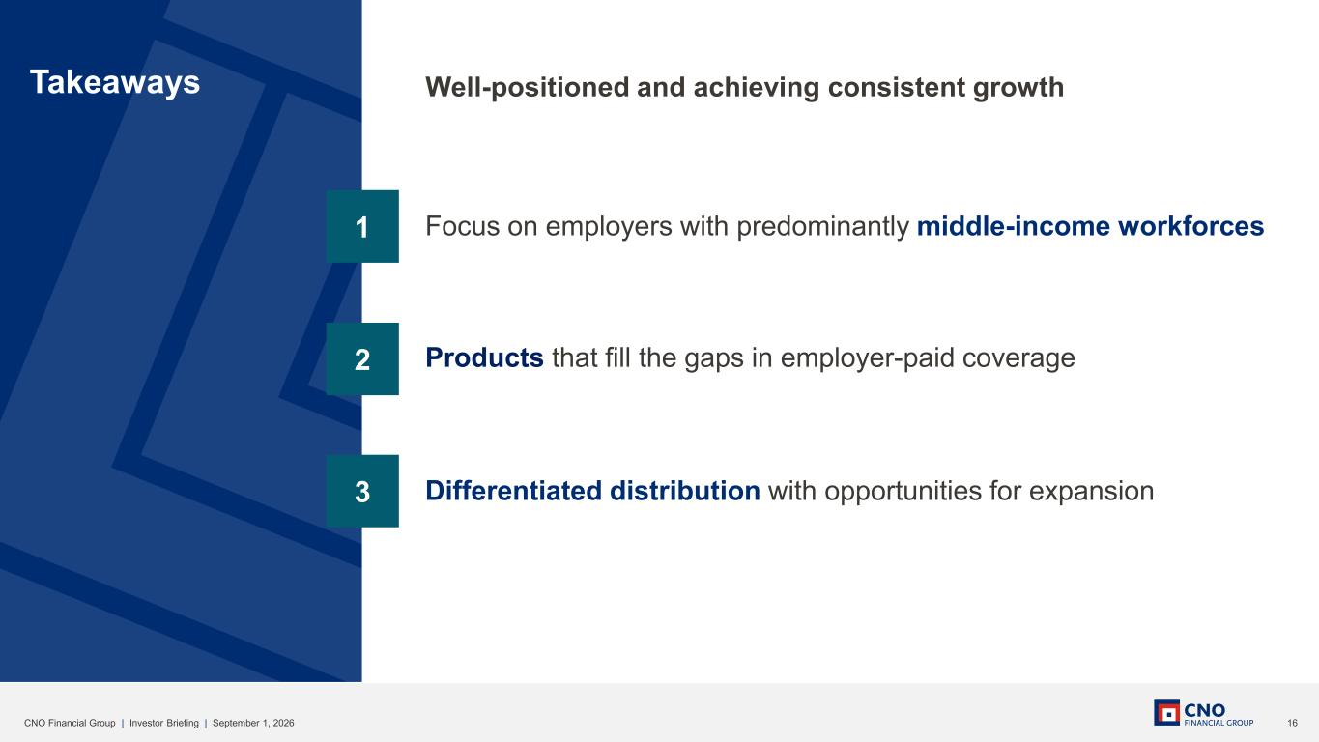
16CNO Financial Group | Investor Briefing | September 1, 2026 3 2 1 Takeaways Focus on employers with predominantly middle-income workforces Products that fill the gaps in employer-paid coverage Differentiated distribution with opportunities for expansion Well-positioned and achieving consistent growth

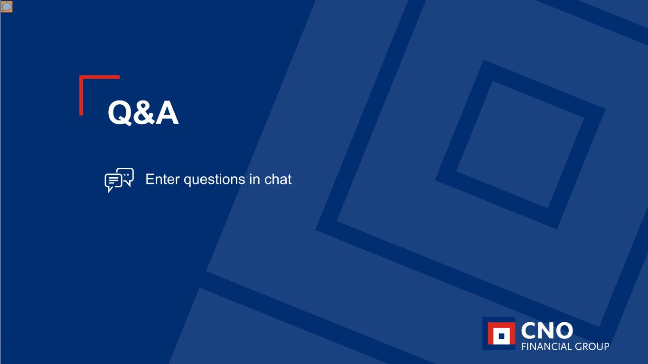
17CNO Financial Group | Investor Briefing | September 1, 2026 Q&A Enter questions in chat

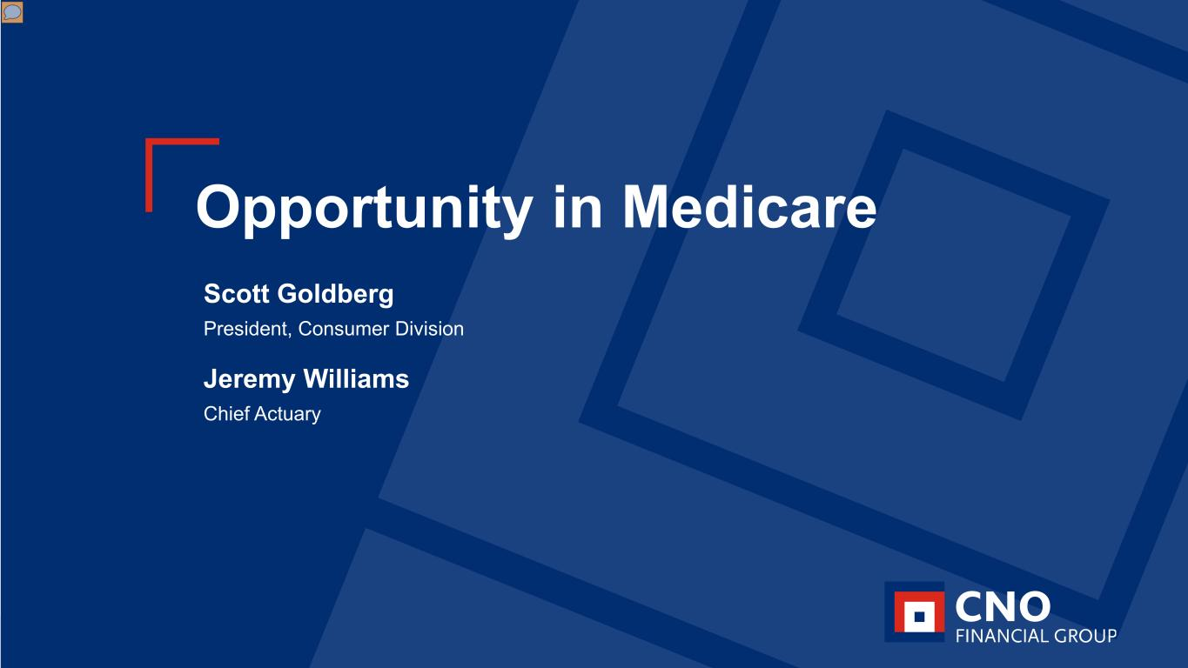
18CNO Financial Group | Investor Briefing | September 1, 2026 Opportunity in Medicare Scott Goldberg President, Consumer Division Jeremy Williams Chief Actuary

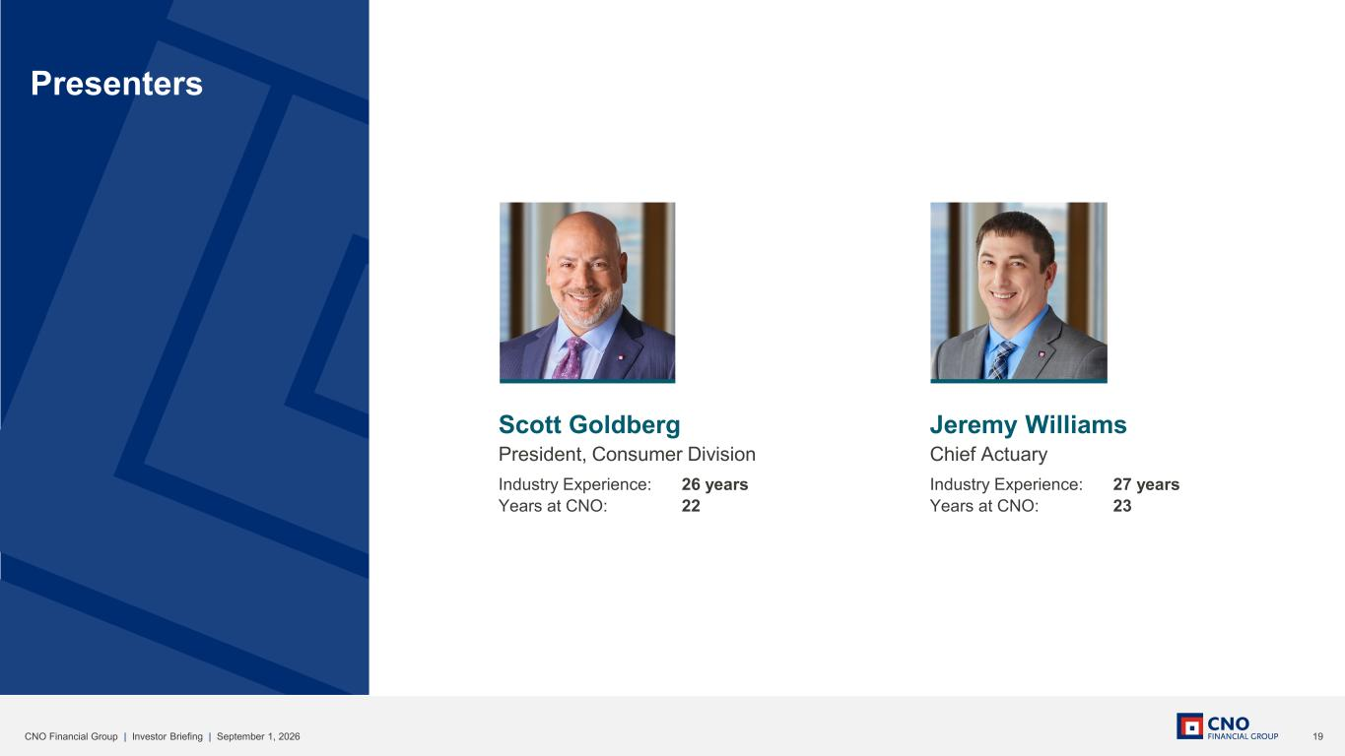
19CNO Financial Group | Investor Briefing | September 1, 2026 Scott Goldberg President, Consumer Division Industry Experience: 26 years Years at CNO: 22 Presenters Jeremy Williams Chief Actuary Industry Experience: 27 years Years at CNO: 23

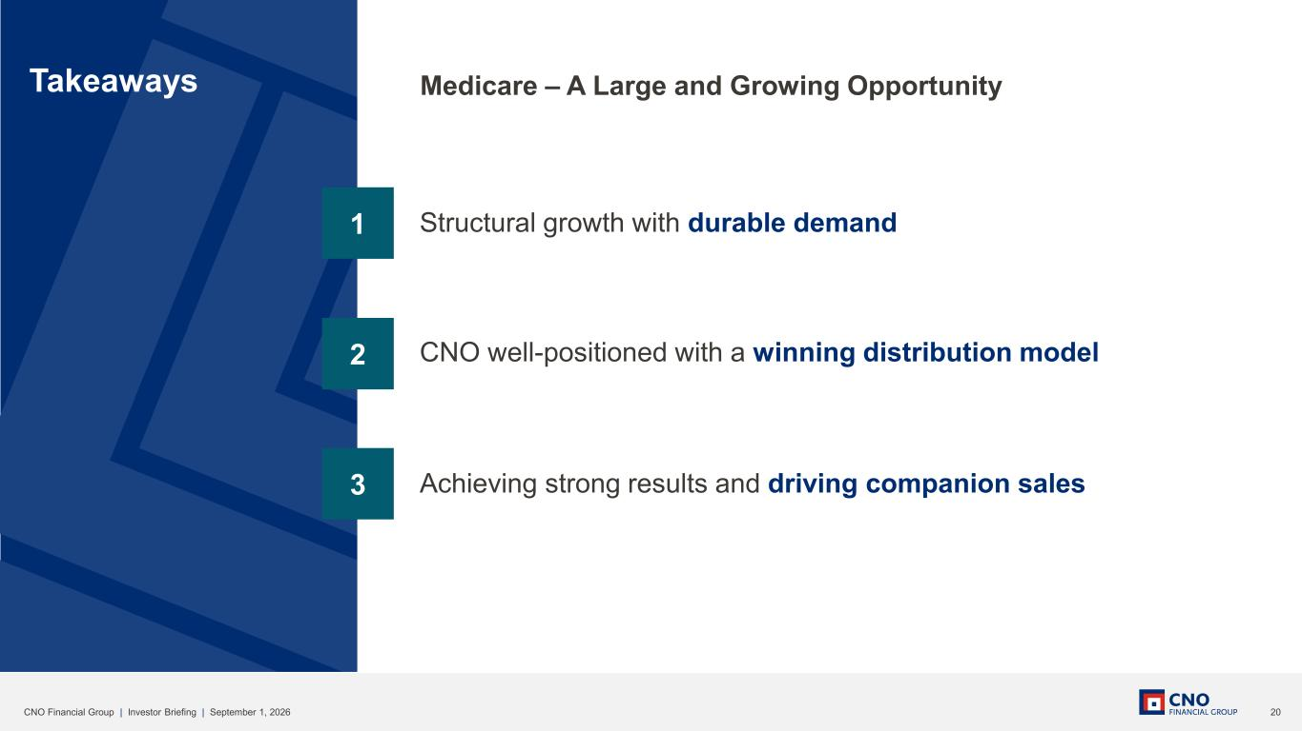
20CNO Financial Group | Investor Briefing | September 1, 2026 3 2 1 Takeaways Structural growth with durable demand CNO well-positioned with a winning distribution model Achieving strong results and driving companion sales Medicare – A Large and Growing Opportunity

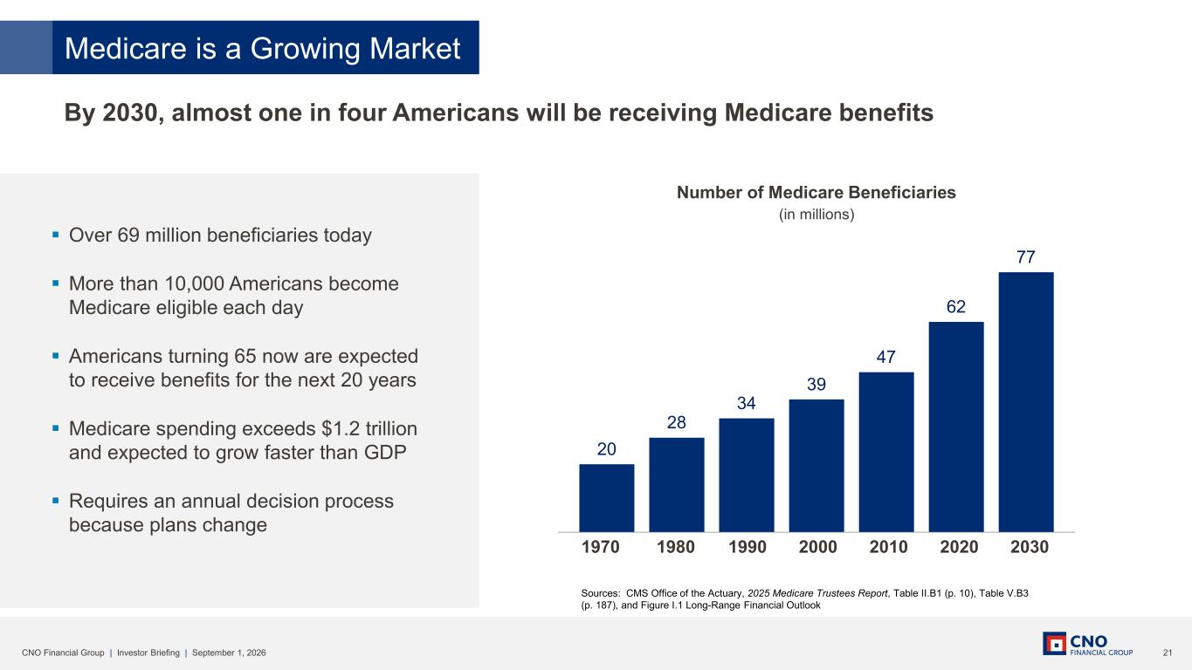
21CNO Financial Group | Investor Briefing | September 1, 2026 ▪ Over 69 million beneficiaries today ▪ More than 10,000 Americans become Medicare eligible each day ▪ Americans turning 65 now are expected to receive benefits for the next 20 years ▪ Medicare spending exceeds $1.2 trillion and expected to grow faster than GDP ▪ Requires an annual decision process because plans change Medicare is a Growing Market By 2030, almost one in four Americans will be receiving Medicare benefits 20 28 34 39 47 62 77 1970 1980 1990 2000 2010 2020 2030 Number of Medicare Beneficiaries (in millions) Sources: CMS Office of the Actuary, 2025 Medicare Trustees Report, Table II.B1 (p. 10), Table V.B3 (p. 187), and Figure I.1 Long-Range Financial Outlook

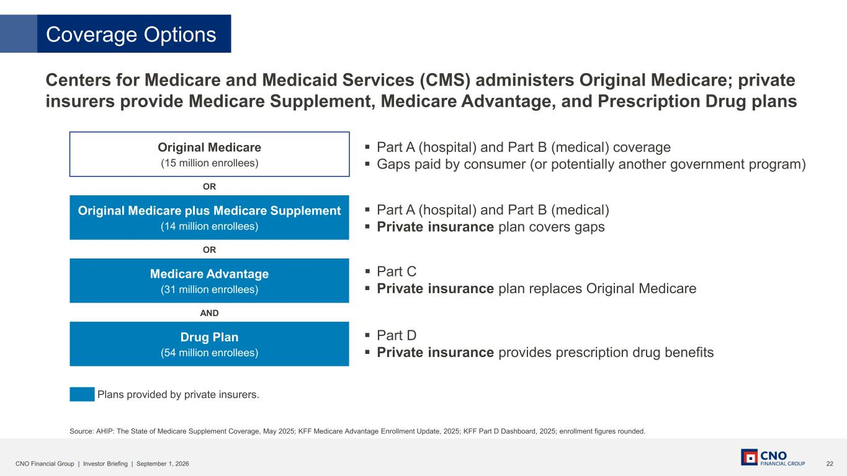
22CNO Financial Group | Investor Briefing | September 1, 2026 Coverage Options Centers for Medicare and Medicaid Services (CMS) administers Original Medicare; private insurers provide Medicare Supplement, Medicare Advantage, and Prescription Drug plans Source: AHIP: The State of Medicare Supplement Coverage, May 2025; KFF Medicare Advantage Enrollment Update, 2025; KFF Part D Dashboard, 2025; enrollment figures rounded. OR Original Medicare (15 million enrollees) Original Medicare plus Medicare Supplement (14 million enrollees) Medicare Advantage (31 million enrollees) Drug Plan (54 million enrollees) ▪ Part A (hospital) and Part B (medical) coverage ▪ Gaps paid by consumer (or potentially another government program) ▪ Part A (hospital) and Part B (medical) ▪ Private insurance plan covers gaps ▪ Part C ▪ Private insurance plan replaces Original Medicare ▪ Part D ▪ Private insurance provides prescription drug benefits Plans provided by private insurers. OR AND

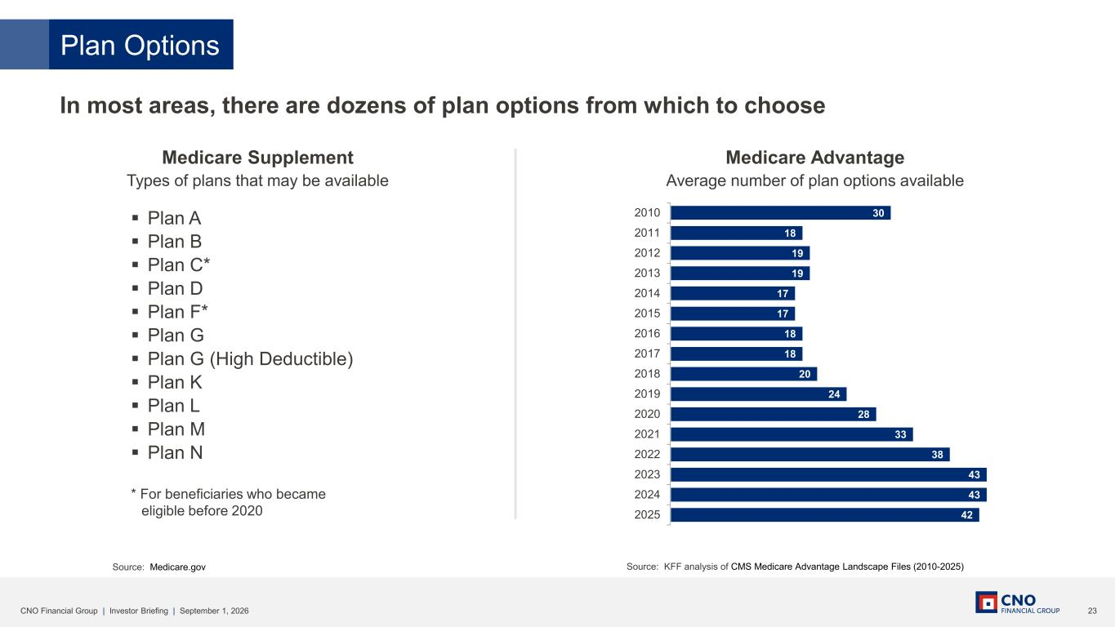
23CNO Financial Group | Investor Briefing | September 1, 2026 Plan Options In most areas, there are dozens of plan options from which to choose Source: KFF analysis of CMS Medicare Advantage Landscape Files (2010-2025) Medicare Supplement Types of plans that may be available Medicare Advantage Average number of plan options available ▪ Plan A ▪ Plan B ▪ Plan C* ▪ Plan D ▪ Plan F* ▪ Plan G ▪ Plan G (High Deductible) ▪ Plan K ▪ Plan L ▪ Plan M ▪ Plan N * For beneficiaries who became eligible before 2020 Source: Medicare.gov 30 18 19 19 17 17 18 18 20 24 28 33 38 43 43 42 2010 2011 2012 2013 2014 2015 2016 2017 2018 2019 2020 2021 2022 2023 2024 2025

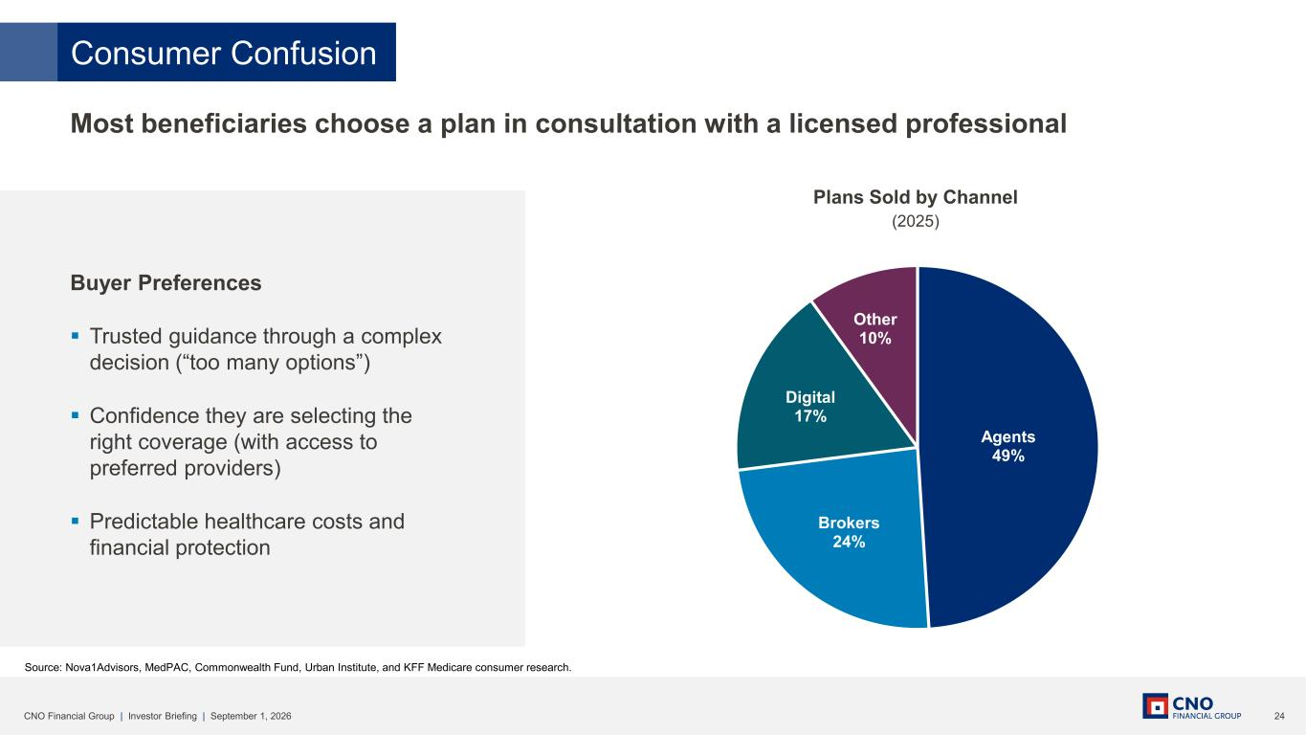
24CNO Financial Group | Investor Briefing | September 1, 2026 Consumer Confusion Most beneficiaries choose a plan in consultation with a licensed professional Agents 49% Brokers 24% Digital 17% Other 10% Source: Nova1Advisors, MedPAC, Commonwealth Fund, Urban Institute, and KFF Medicare consumer research. Buyer PreferencesBuyer Preferences ▪ Trusted guidance through a complex decision (“too many options”) ▪ Confidence they are selecting the right coverage (with access to preferred providers) ▪ Predictable healthcare costs and financial protection Plans Sold by Channel (2025)

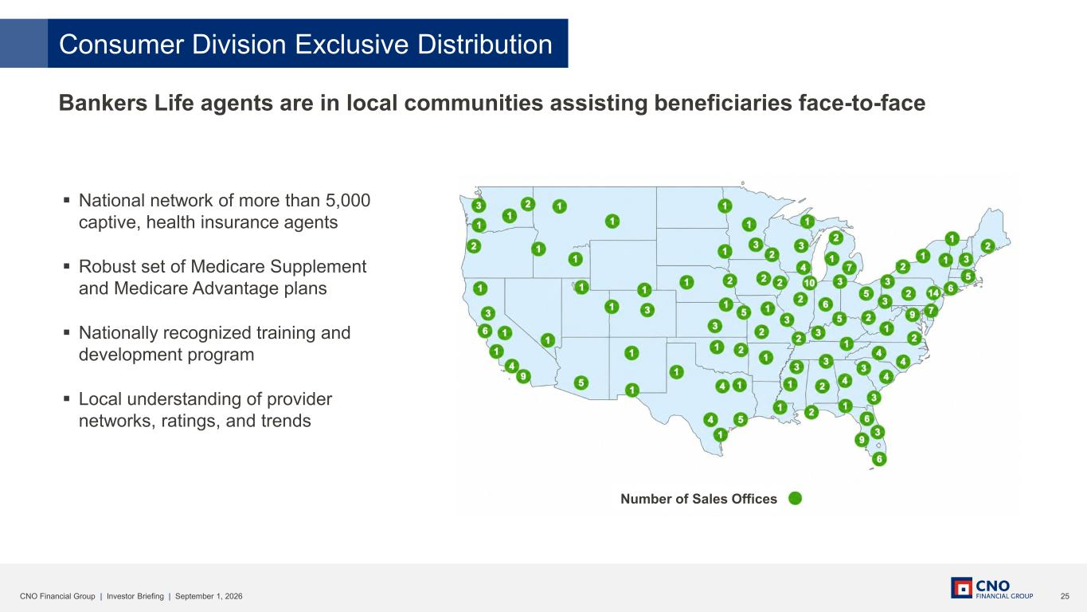
25CNO Financial Group | Investor Briefing | September 1, 2026 Consumer Division Exclusive Distribution Bankers Life agents are in local communities assisting beneficiaries face-to-face ▪ National network of more than 5,000 captive, health insurance agents ▪ Robust set of Medicare Supplement and Medicare Advantage plans ▪ Nationally recognized training and development program ▪ Local understanding of provider networks, ratings, and trends Number of Sales Offices

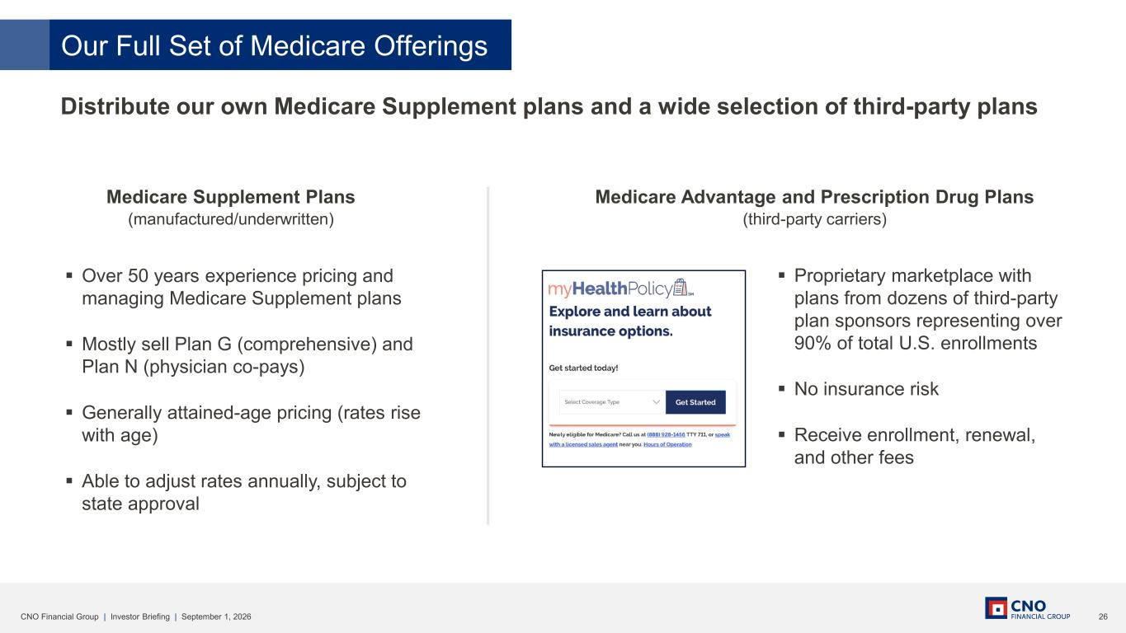
26CNO Financial Group | Investor Briefing | September 1, 2026 ▪ Over 50 years experience pricing and managing Medicare Supplement plans ▪ Mostly sell Plan G (comprehensive) and Plan N (physician co-pays) ▪ Generally attained-age pricing (rates rise with age) ▪ Able to adjust rates annually, subject to state approval Our Full Set of Medicare Offerings Distribute our own Medicare Supplement plans and a wide selection of third-party plans Medicare Advantage and Prescription Drug Plans (third-party carriers) ▪ Proprietary marketplace with plans from dozens of third-party plan sponsors representing over 90% of total U.S. enrollments ▪ No insurance risk ▪ Receive enrollment, renewal, and other fees Medicare Supplement Plans (manufactured/underwritten)

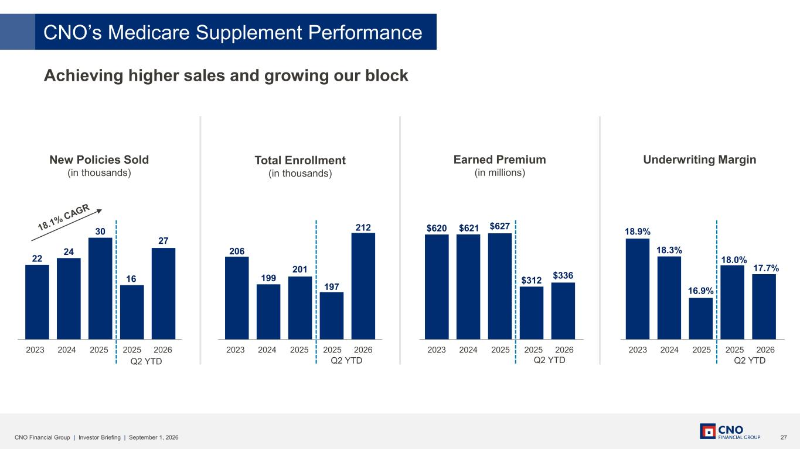
27CNO Financial Group | Investor Briefing | September 1, 2026 18.9% 18.3% 16.9% 18.0% 17.7% $620 $621 $627 $312 $336 206 199 201 197 212 22 24 30 16 27 CNO’s Medicare Supplement Performance Achieving higher sales and growing our block New Policies Sold (in thousands) Total Enrollment (in thousands) Earned Premium (in millions) Underwriting Margin Q2 YTD 2023 2024 2025 2025 2026 Q2 YTD 2023 2024 2025 2025 2026 Q2 YTD 2023 2024 2025 2025 2026 Q2 YTD 2023 2024 2025 2025 2026

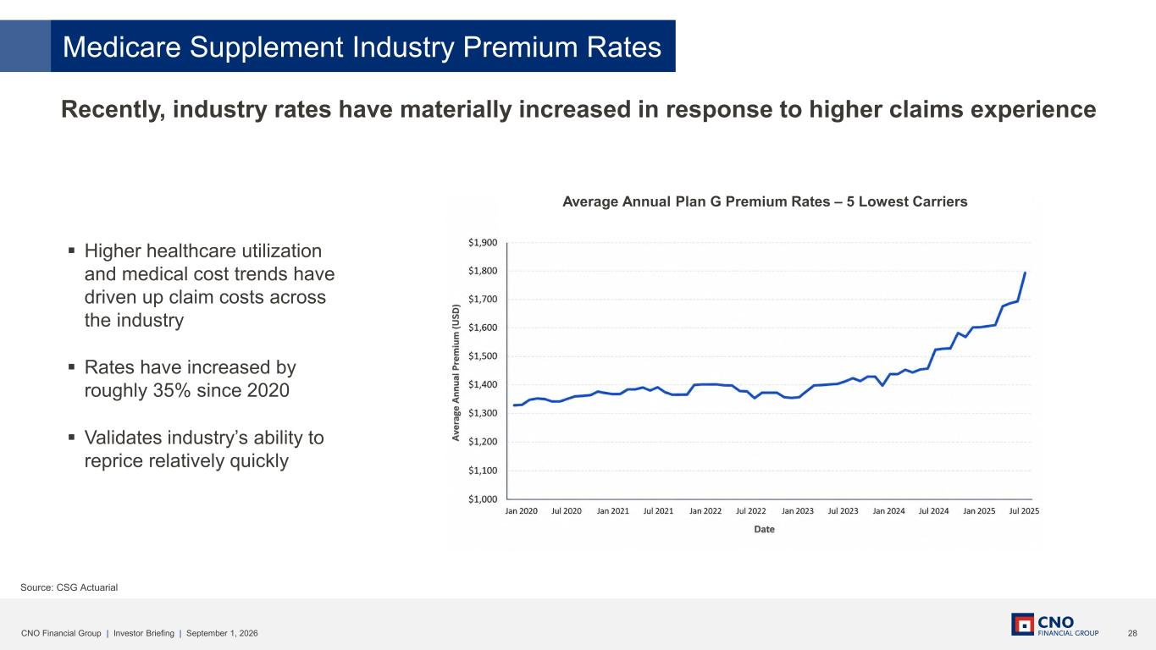
28CNO Financial Group | Investor Briefing | September 1, 2026 Source: CSG Actuarial ▪ Higher healthcare utilization and medical cost trends have driven up claim costs across the industry ▪ Rates have increased by roughly 35% since 2020 ▪ Validates industry’s ability to reprice relatively quickly Recently, industry rates have materially increased in response to higher claims experience Medicare Supplement Industry Premium Rates Average Annual Plan G Premium Rates – 5 Lowest Carriers

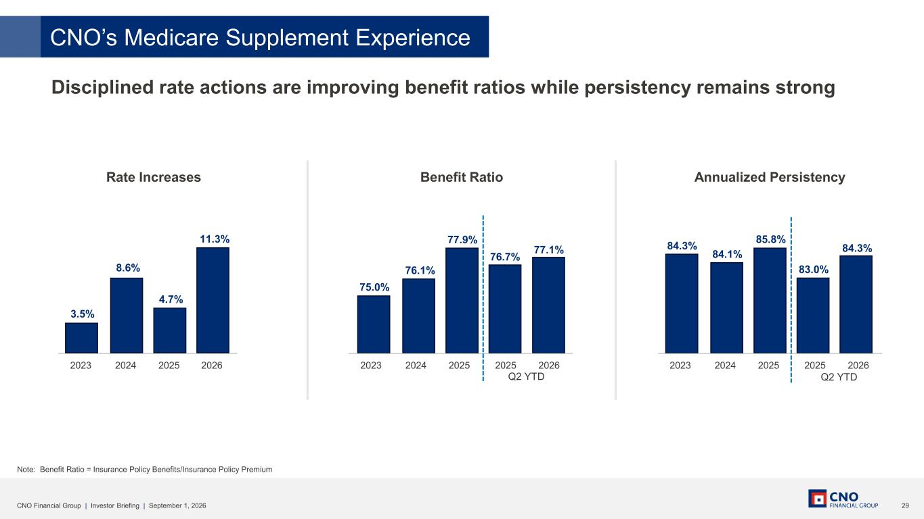
29CNO Financial Group | Investor Briefing | September 1, 2026 Disciplined rate actions are improving benefit ratios while persistency remains strong Note: Benefit Ratio = Insurance Policy Benefits/Insurance Policy Premium Rate Increases Benefit Ratio Annualized Persistency 3.5% 8.6% 4.7% 11.3% 2023 2024 2025 2026 75.0% 76.1% 77.1% 77.9% 76.7% 2023 2024 2025 2025 2026 Q2 YTD 84.3% 84.1% 85.8% 84.3% 83.0% 2023 2024 2025 2025 2026 Q2 YTD CNO’s Medicare Supplement Experience

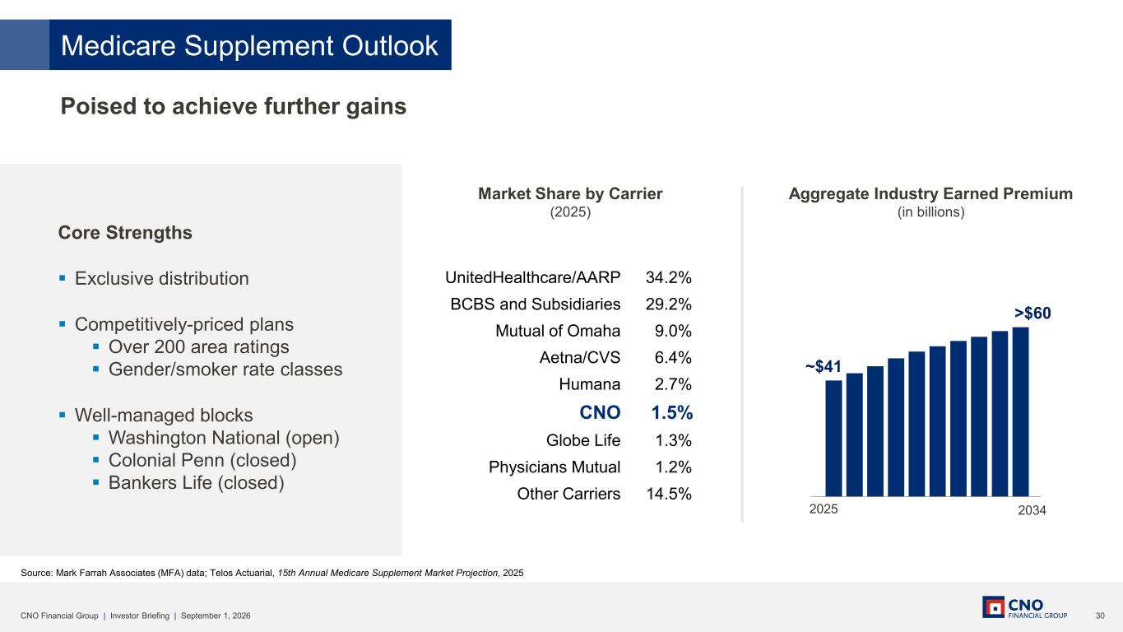
30CNO Financial Group | Investor Briefing | September 1, 2026 Source: Mark Farrah Associates (MFA) data; Telos Actuarial, 15th Annual Medicare Supplement Market Projection, 2025 ~$41 >$60 2025 2034 UnitedHealthcare/AARP BCBS and Subsidiaries Mutual of Omaha Aetna/CVS Humana CNO Globe Life Physicians Mutual Other Carriers Poised to achieve further gains Core Strengths ▪ Exclusive distribution ▪ Competitively-priced plans ▪ Over 200 area ratings ▪ Gender/smoker rate classes ▪ Well-managed blocks ▪ Washington National (open) ▪ Colonial Penn (closed) ▪ Bankers Life (closed) Market Share by Carrier (2025) Aggregate Industry Earned Premium (in billions) 34.2% 29.2% 9.0% 6.4% 2.7% 1.5% 1.3% 1.2% 14.5% Medicare Supplement Outlook

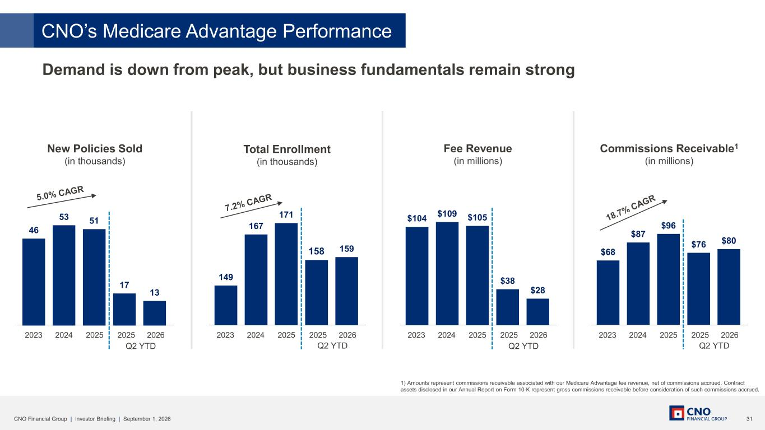
31CNO Financial Group | Investor Briefing | September 1, 2026 Demand is down from peak, but business fundamentals remain strong New Policies Sold (in thousands) Total Enrollment (in thousands) Fee Revenue (in millions) Commissions Receivable1 (in millions) Q2 YTD 2023 2024 2025 2025 2026 46 53 51 17 13 Q2 YTD 2023 2024 2025 2025 2026 149 167 171 158 159 Q2 YTD 2023 2024 2025 2025 2026 $104 $109 $105 $38 $28 $68 $87 $96 $76 $80 Q2 YTD 2023 2024 2025 2025 2026 CNO’s Medicare Advantage Performance 1) Amounts represent commissions receivable associated with our Medicare Advantage fee revenue, net of commissions accrued. Contract assets disclosed in our Annual Report on Form 10-K represent gross commissions receivable before consideration of such commissions accrued.

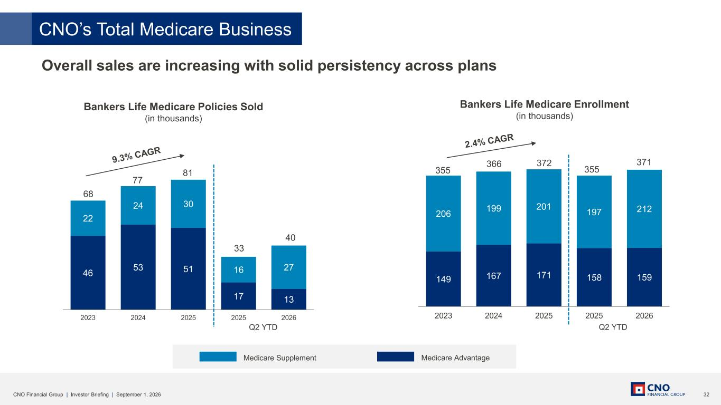
32CNO Financial Group | Investor Briefing | September 1, 2026 149 167 171 158 159 206 199 201 197 212 2023 2024 2025 2025 2026 46 53 51 17 13 22 24 30 16 27 2023 2024 2025 2025 2026 Bankers Life Medicare Enrollment (in thousands) Bankers Life Medicare Policies Sold (in thousands) Medicare Supplement Medicare Advantage 355 366 372 68 77 81 Overall sales are increasing with solid persistency across plans CNO’s Total Medicare Business 33 40 Q2 YTD 355 371 Q2 YTD

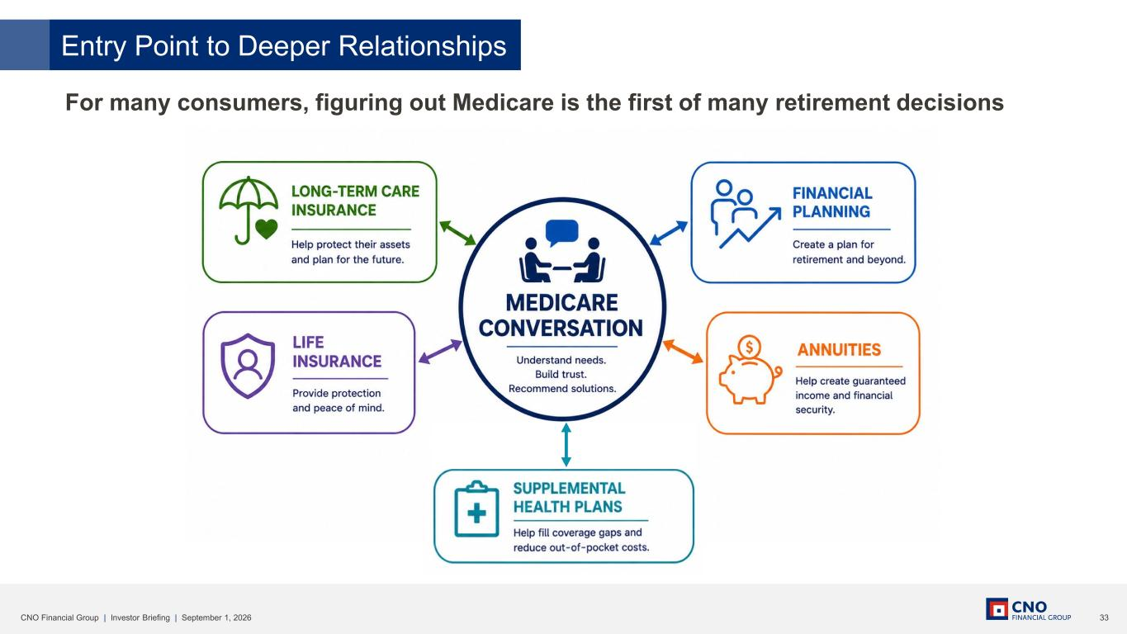
33CNO Financial Group | Investor Briefing | September 1, 2026 For many consumers, figuring out Medicare is the first of many retirement decisions Entry Point to Deeper Relationships

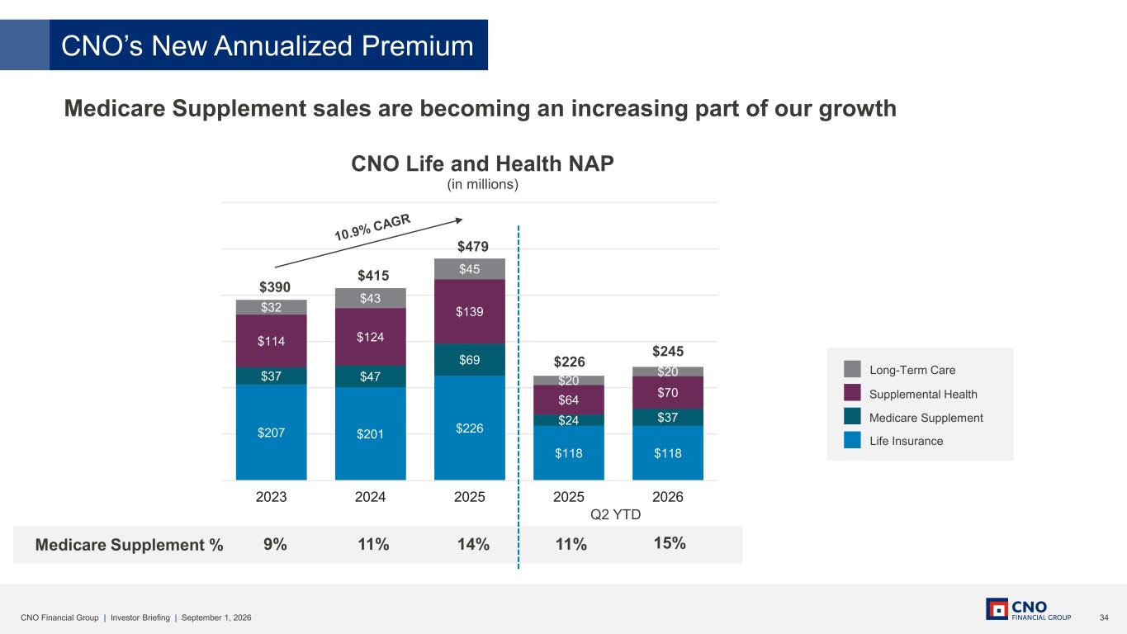
34CNO Financial Group | Investor Briefing | September 1, 2026 Medicare Supplement % 9% 11% 14% 15%11% Medicare Supplement sales are becoming an increasing part of our growth Long-Term Care Supplemental Health Medicare Supplement Life Insurance CNO’s New Annualized Premium $207 $201 $226 $118 $118 $37 $47 $69 $24 $37 $114 $124 $139 $64 $70 $32 $43 $45 $20 $20 2023 2024 2025 2025 2026 CNO Life and Health NAP (in millions) $390 $415 $479 $226 $245 Q2 YTD

35CNO Financial Group | Investor Briefing | September 1, 2026 Voices From The Field

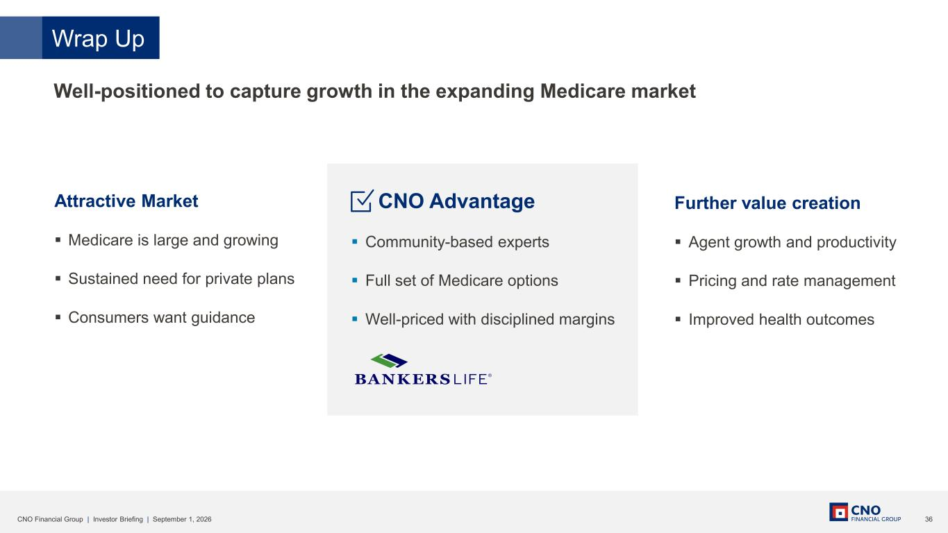
36CNO Financial Group | Investor Briefing | September 1, 2026 Attractive Market ▪ Medicare is large and growing ▪ Sustained need for private plans ▪ Consumers want guidance Wrap Up Further value creation ▪ Agent growth and productivity ▪ Pricing and rate management ▪ Improved health outcomes CNO Advantage ▪ Community-based experts ▪ Full set of Medicare options ▪ Well-priced with disciplined margins Well-positioned to capture growth in the expanding Medicare market

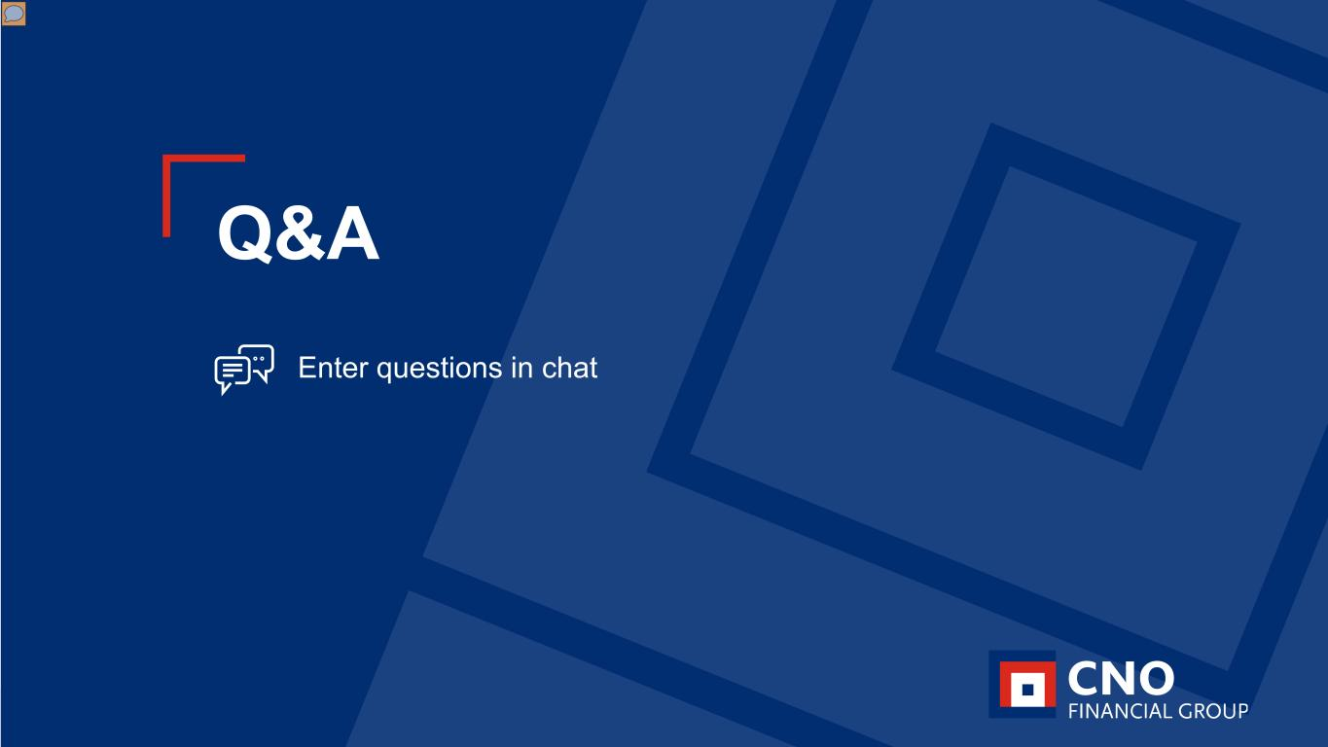
37CNO Financial Group | Investor Briefing | September 1, 2026 Q&A Enter questions in chat

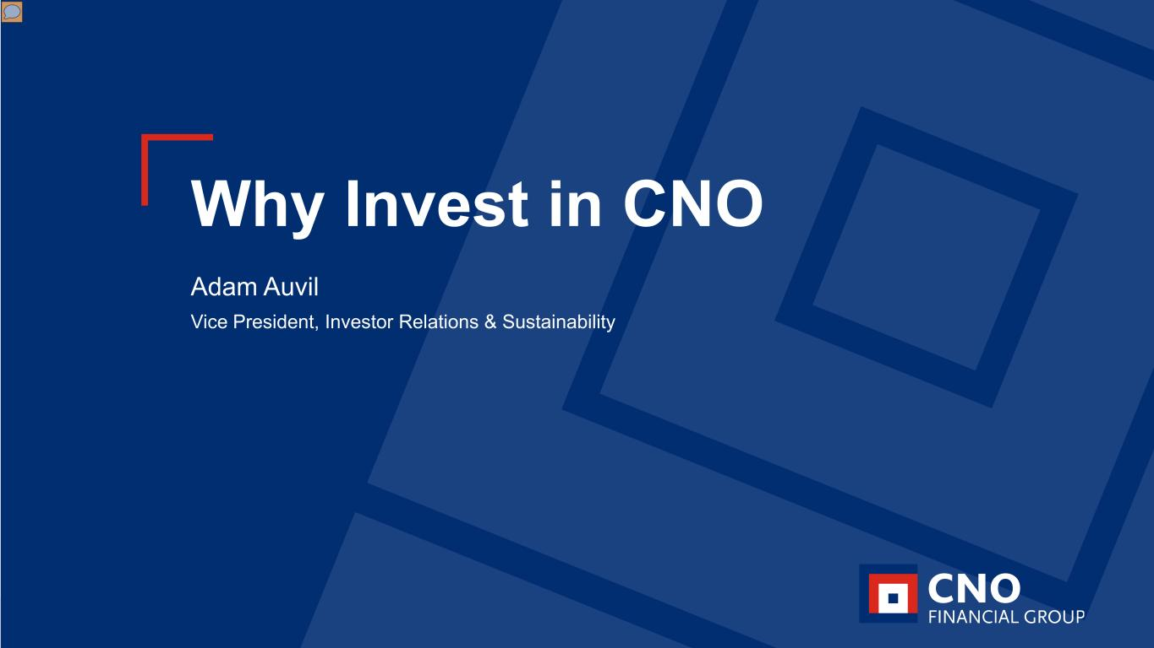
38CNO Financial Group | Investor Briefing | September 1, 2026 Why Invest in CNO Adam Auvil Vice President, Investor Relations & Sustainability

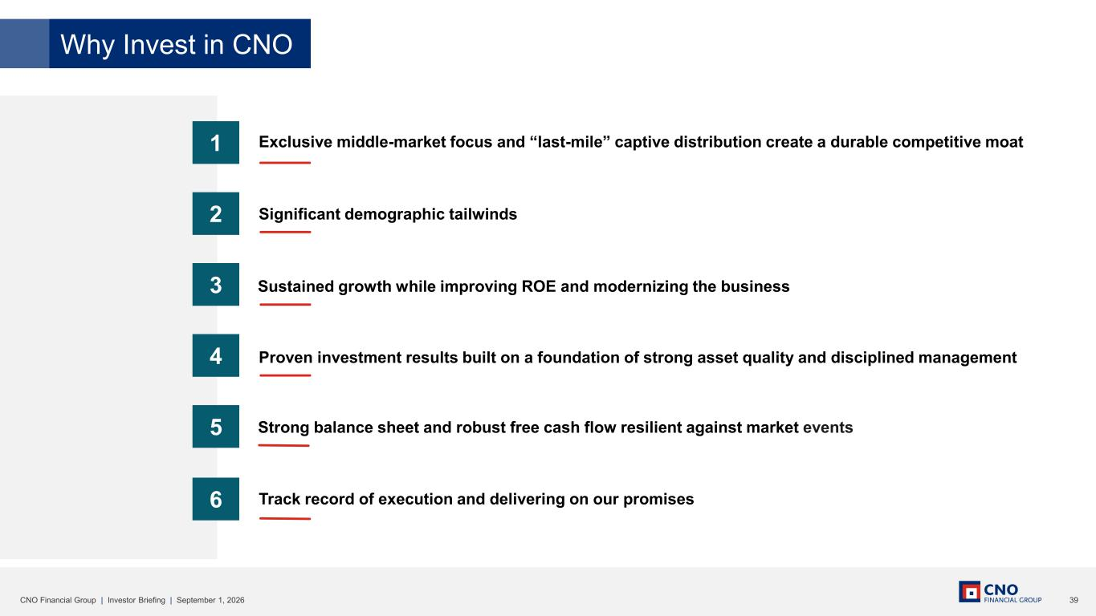
39CNO Financial Group | Investor Briefing | September 1, 2026 Why Invest in CNO 4 5 3 2 1 Exclusive middle-market focus and “last-mile” captive distribution create a durable competitive moat Significant demographic tailwinds Proven investment results built on a foundation of strong asset quality and disciplined management Strong balance sheet and robust free cash flow resilient against market events 6 Track record of execution and delivering on our promises Sustained growth while improving ROE and modernizing the business

40CNO Financial Group | Investor Briefing | September 1, 2026 CNO Financial Group Investor Briefing September 1, 2026

